S3, Cloud front, R53

1. Purchase one domain from GoDaddy
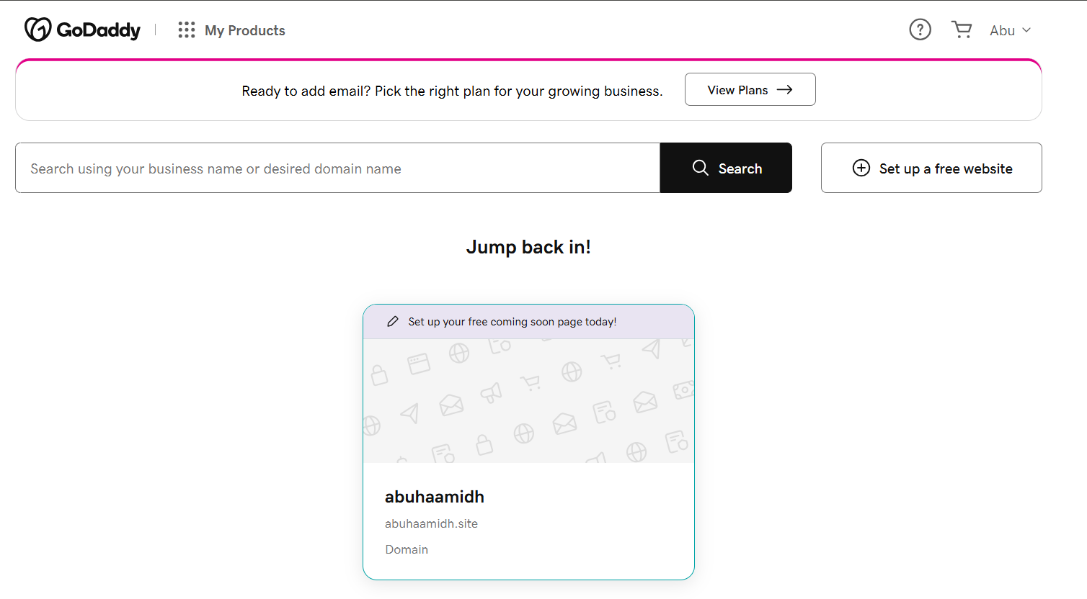

2. Deploy static website in S3
For deploying the static website in S3, first we need to create a bucket with ACL disabled and uncheck the block public access
Update the bucket policy to have the permission
Then upload two files in the proper .html format, to avoid file format error
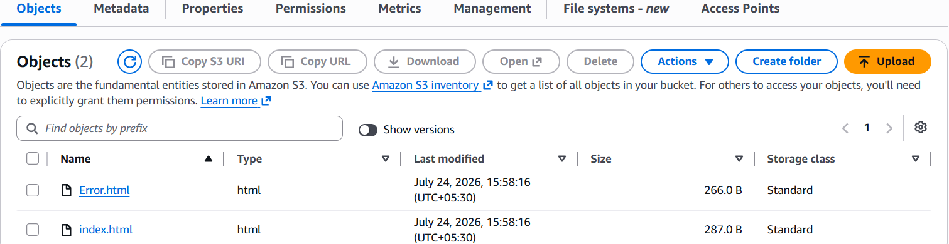
Now in the bucket properties, at the end you can see the bucket website endpoint
Copy that URL and check it in the browser, it displays the content as shown below
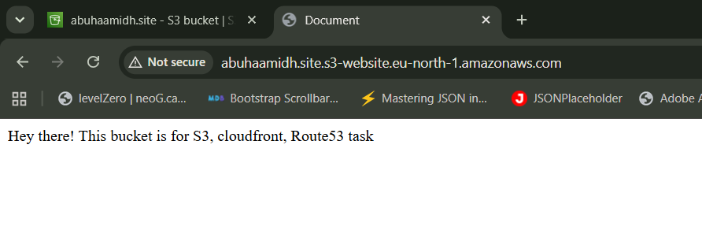

3. Create a CDN and attach one SSL certificate
In the ACM, you can see the request button, by clicking that you can request for a certifiacte
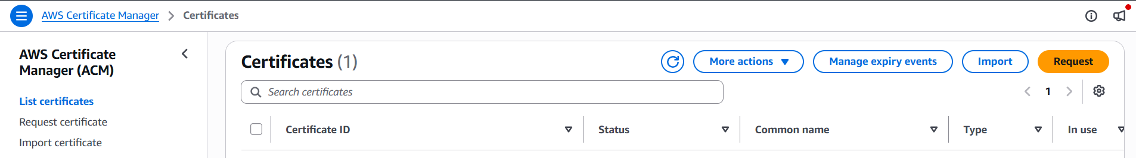
We can go with public certificate, its enough for us
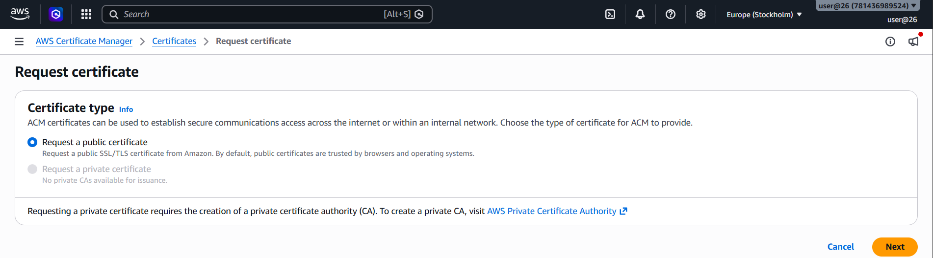
Once you request, It takes few min to provide,
Meanwhile we need to create a records in route 53,
When you add this record to Route 53, you are essentially telling the global DNS system: Amazon Certificate Manager is authorized to validate this domain.
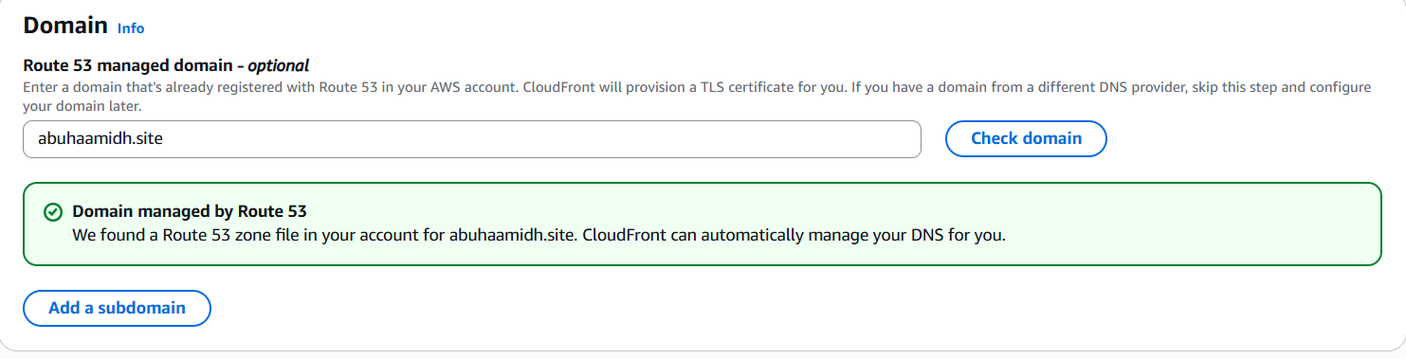

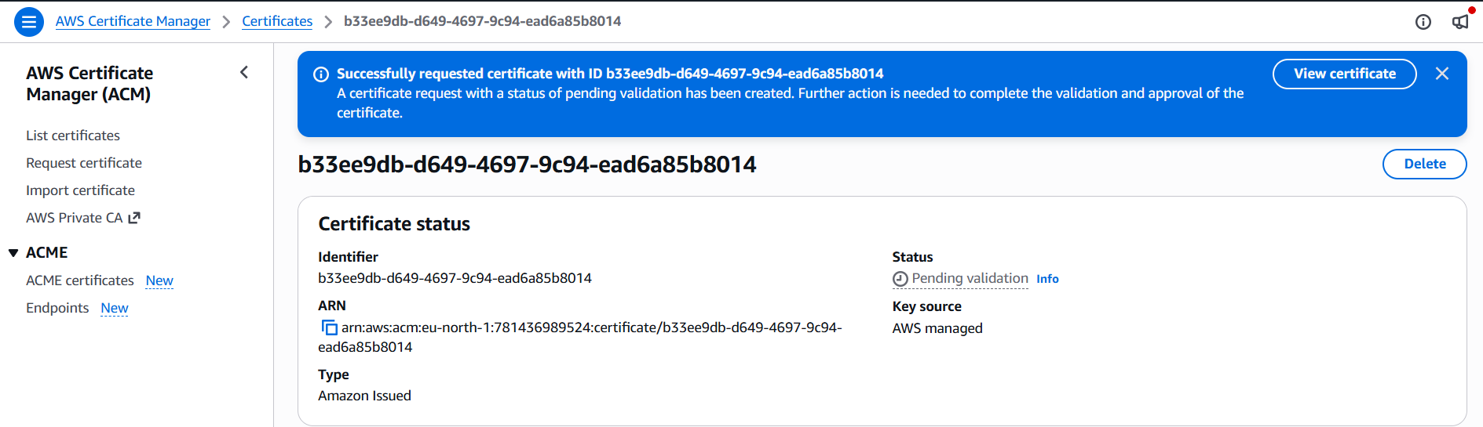
So the certificate has been issued successfully, Now while creating the Cloud front you can attach this certificate there as shown below
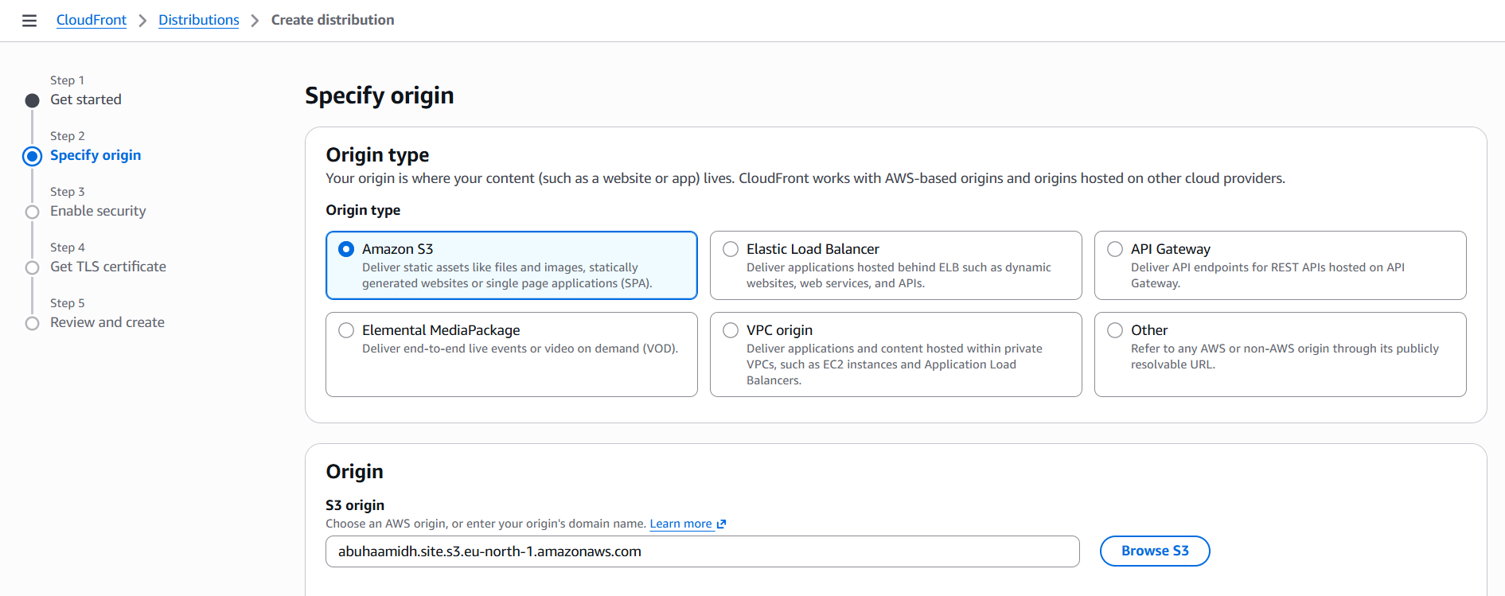
Attach the origin path of the bucket where it can fetch the content from s3 bucket
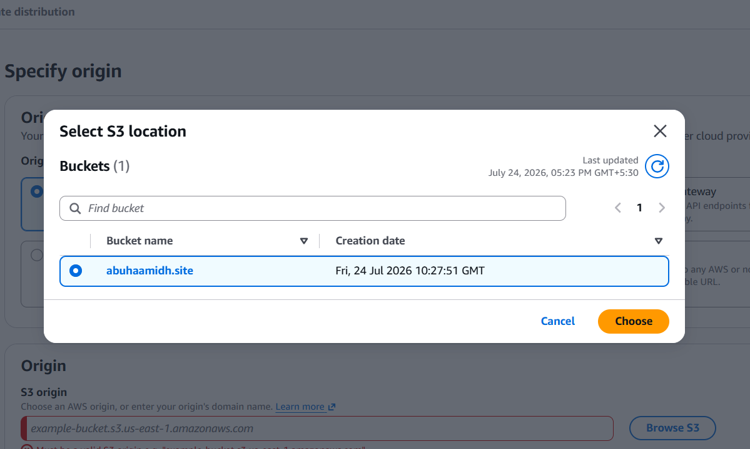
Disable the firewall
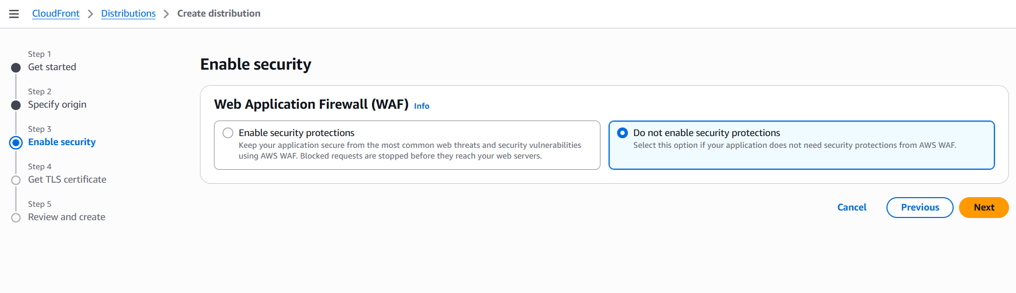
Attach the certificate with the cloudfront
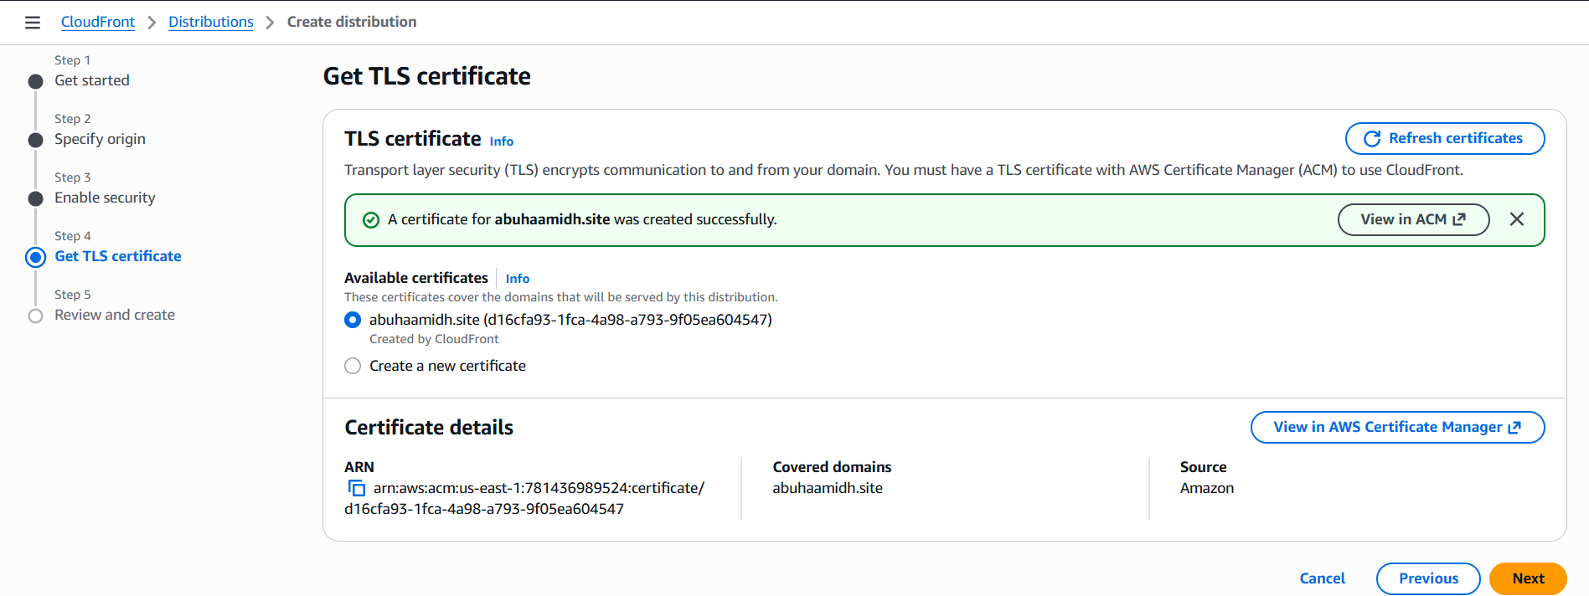
Then configure this settings in the cloudfront, off the IPv6
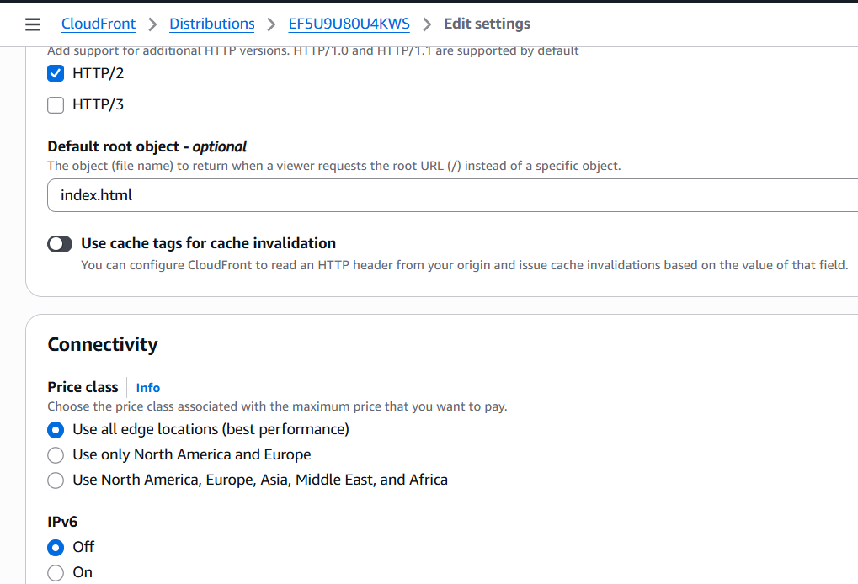
Create record and attach the alias to route the traffic
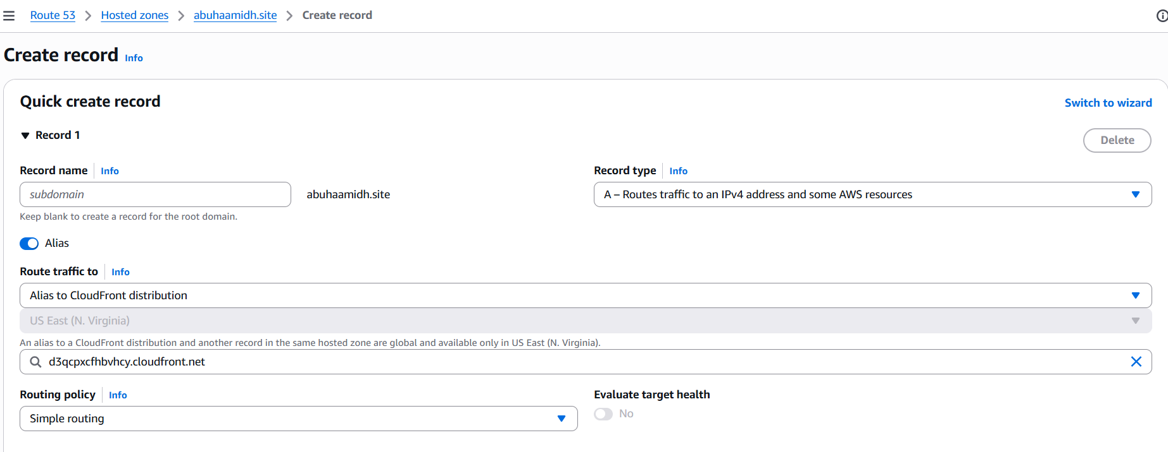

4. Create a Route 53 hosted zone and map the domain with the CDN
Now go to Route53 and click on hosted zone and click on create records
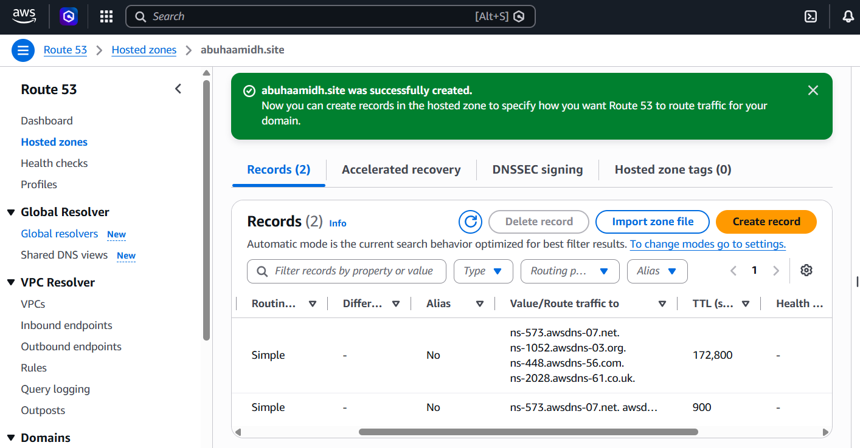
After creating records you can see there are 4 route traffic has been created and you need to attach it to your domain provider(Go daddy)
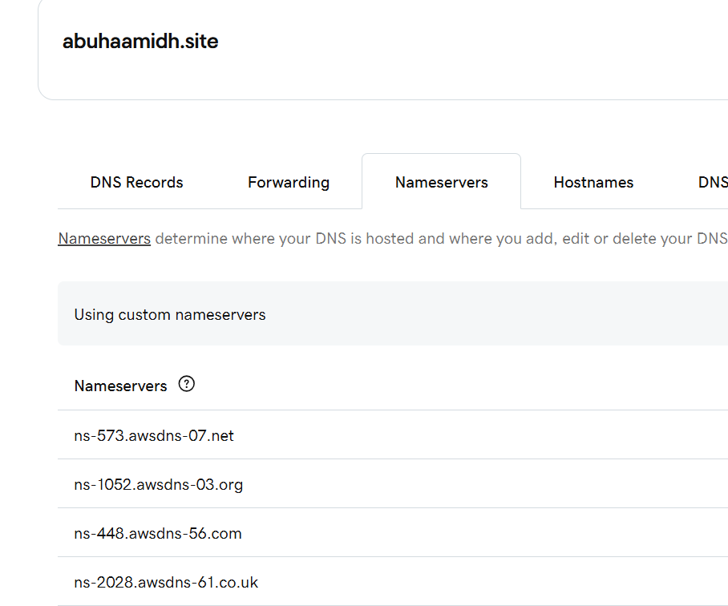
So, It has been merged

5. Update the index.html in the S3 bucket and ensure the updated file is accessible using the domain name.
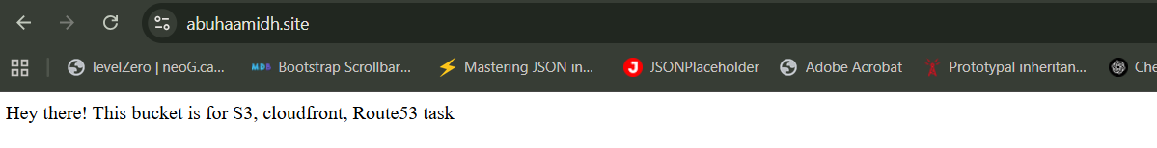

6. Share the domain name in Slack to test the connectivity.
It has been shared and checked the connection and its working

